PRODUCT SPOTLIGHT - GEMINI TRUCK BLOCK SETS

June 22, 2018

Dear Scan-Pac Customer,
Scan-Pac Manufacturing would like to highlight the effectiveness of our Gemini Truck Brake Friction Blocks for use on over-the-road trucks and buses. Scan-Pac offers two truck block materials, GEM200 and GEM301. GEM200 has been independently tested to FMVSS 121 and approved for semi-trucks up to 20,000 lb. axle weight. GEM301 has been independently tested to 23,000 lb. axle weight. Both materials offer excellent fade and recovery in addition to low wear rates on the friction and mating surfaces.
Truck Brake Blocks offer another addition to Scan-Pac Manufacturing’s family of Gemini friction products. Our blocks perform at a high level on truck braking systems, while maintaining the value offered by the Gemini family of products.
Scan-Pac is pleased to offer several of the most popular truck block sets on the market. All sets are available in both 20,000 and 23,000 lb. axle weight ratings. In addition, all truck blocks come carefully packed in individual boxes. Truck blocks usually ship within 1-2 days of the order date.
Application and GEM200/GEM301 Material Pictures
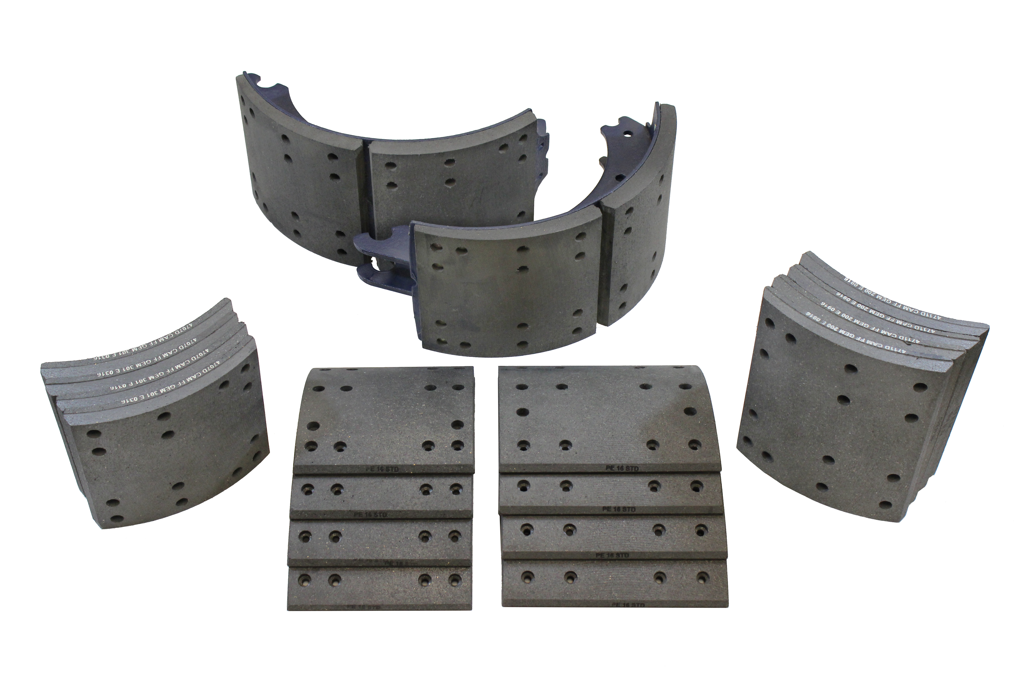

- Request a sample and a price list today. We can ship truck brake blocks within 1-2 days after receipt of your order.
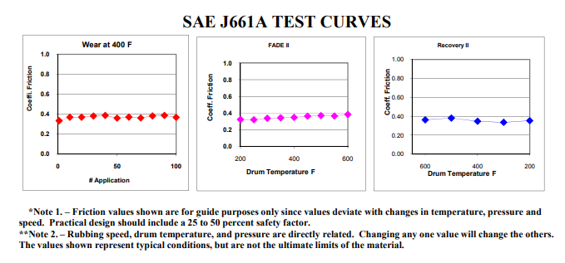
Scan-Pac Manufacturing continues to be the industry leader in development of new friction materials for challenging applications. The company employs two PhD chemists who are devoted to designing the highest performing friction materials on the market. Next time you need a friction material, or when an off-the-shelf formulation does not meet your requirements, please give our R&D experts the opportunity to work with you.

Scan-Pac Mfg. is a manufacturer of non-asbestos friction materials and phenolic laminates for use in a wide range of industrial and oilfield applications. The company has three manufacturing locations that include two facilities in Menomonee Falls, Wisconsin and one in Magnolia, Texas. Scan-Pac employs more than 100 individuals and has proudly and successfully been in business for more than 40 years.
Check out our website and download our Scan-Pac App using the links below, or find it on the App Store or Google Play.
Thanks and best regards,
Jeff Lichey
VP, Sales & Marketing

