PRODUCT SPOTLIGHT – GGW & GEMINI WOVEN FRICTION

August 31, 2018

Dear Scan-Pac Customer,
Scan-Pac Manufacturing would like to highlight the effectiveness of our GGW and Gemini woven friction materials because of their high coefficients of friction and low wear rates. Our woven materials are manufactured on industrial weaving looms along with precision controlled friction saturants at our manufacturing facility in Magnolia, Texas. These materials are flexible and therefore ideal for use on internal or external brake bands or shoes.
The tightly woven dense construction of Gemini and GGW woven materials provides premium life characteristics. In addition, these asbestos free linings are not fazed by oil, grease, or water. Our woven materials are sold in 25 foot rolls or as Oilfield brake block sets with drilled holes and grooves (hardware included).
These materials are specifically designed for holding and stopping with the least amount of abrasion. Typical applications include oilfield workover and drilling rigs, mine winches, mooring winches, elevators, and several more.
Oilfield & Winch Application Photos Gemini & GGW Linings

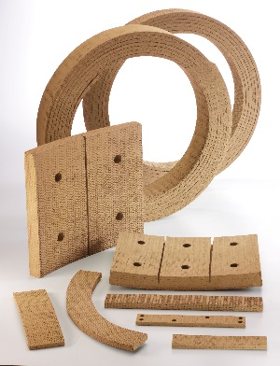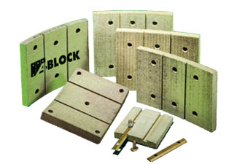

- Request a sample and a price list today.
- We can ship these woven linings within 3-5 days after receipt of your order.
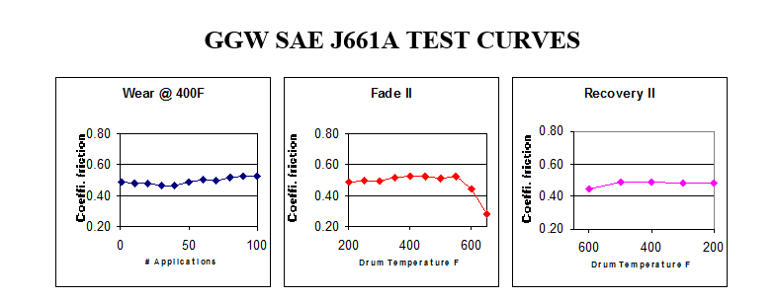
Scan-Pac Manufacturing continues to be the industry leader in development of new friction materials for challenging applications. The company employs two PhD chemists who are devoted to designing the highest performing friction materials on the market. Next time you need a friction material, or when an off-the-shelf formulation does not meet your requirements, please give our R&D experts the opportunity to work with you.

Scan-Pac Mfg. is a manufacturer of non-asbestos friction materials and phenolic laminates for use in a wide range of industrial and oilfield applications. The company has three manufacturing locations that include two facilities in Menomonee Falls, Wisconsin and one in Magnolia, Texas. Scan-Pac has proudly and successfully been in business for more than 45 years.
Check out our website and download our Scan-Pac App using the links below, or find it on the App Store or Google Play.
Thanks and best regards,
Jeff Lichey
VP, Sales & Marketing

