PRODUCT SPOTLIGHT – GATKE HANGER BEARINGS & WEAR PRODUCTS

April 30, 2019

Dear Scan-Pac Customer,
Scan-Pac Manufacturing would like to highlight the effectiveness of our Gatke composite hanger bearings and wear products because of their anti-friction, lubricity, and low wearing characteristics. Gatke hanger bearings are designed to fit standard screw conveyor machines, and the size listings are shown below. Screw conveyors are generally used in processing industries for fine solid products such as grain, citrus, salt, sugar, and other similar products. Gatke hanger bearings are used to align and support screw conveyor equipment.
Several customers have replaced both cast iron and wood bearings with Gatke and discovered that the material offers longer life and a quiet/smooth engagement on screw conveyors. Customers that have made this transition have praised Gatke for decreasing their maintenance cycles and improving overall up-time on their equipment.
The hanger bearings listed below are available in either 112/397 or straight 397 material. The 112/397 material has a fiberglass ID made of 397 and a cotton phenolic ID made of our 112 material. In addition to the sizes below, we also offer various versions of the 3 15/16” hanger bearings for the 309 series and 312 series bearings.
Hanger Bearing Standard Sizes
Hanger Bearing Style | Coupling Diameter | Part Number
216, 16B, 316, 416 | 1” | 309-175-612
216, 16B, 316, 416 | 1 ½” | 309-175-622
216, 16B, 316, 416 | 2” | 309-175-632
216, 16B, 316, 416 | 2 7/16” | 309-175-642
216, 16B, 316, 416 | 3” | 309-175-653
216, 16B, 316, 416 | 3 7/16” | 309-175-663
19B, 219, 18B, 218, 17B, 217 | 1” | 311-175-511
19B, 219, 18B, 218, 17B, 217 | 1 ½” | 311-175-521
19B, 219, 18B, 218, 17B, 217 | 2” | 311-175-531
19B, 219, 18B, 218, 17B, 217 | 2 7/16” | 311-175-542
19B, 219, 18B, 218, 17B, 217 | 3” | 311-175-552
19B, 219, 18B, 218, 17B, 217 | 3 7/16” | 311-175-561
220, 226, 228, 2B, 26B, 28B | 1” | 312-175-412
220, 226, 228, 2B, 26B, 28B | 1 ½” | 312-175-422
220, 226, 228, 2B, 26B, 28B | 2” | 312-175-432
220, 226, 228, 2B, 26B, 28B | 2 7/16” | 312-175-443
220, 226, 228, 2B, 26B, 28B | 3” | 312-175-453
220, 226, 228, 2B, 26B, 28B | 3 7/16” | 312-175-462

These composite materials are made of laminated plastic material produced by impregnating fabrics with a thermosetting resin and dry lubrication compounds. The resultant composite is manufactured under high pressure and temperature to ensure an extremely strong, impact resistant bearing material that can be manufactured to a desired shape or easily machined to specific size and tolerance requirements. Gatke is well known in the industry and is commonly used as a replacement for bronze, Babbitt, and many steel bearings.

Gatke Material Grades

Material Number | 112 (Hydrotex) | 113 (Grafitex) | 118 (Glissentex) | 248TC (Molytex) | 301 Glissentex | 397 | 398
Description | Laminated Medium Weave Cotton Fabric | Laminated Medium Weave Cotton Fabric with Graphite | 112 with laminated with Teflon | Laminated Cotton Fabric with Moly | Laminated Medium Weave Cotton Fabric with Teflon | Laminated Glass Fiber | Laminated Glass Fiber with Graphite Similar to Grafitex A

Product Pictures & Applications

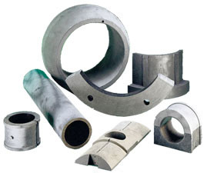 | 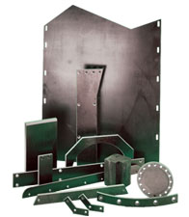 | 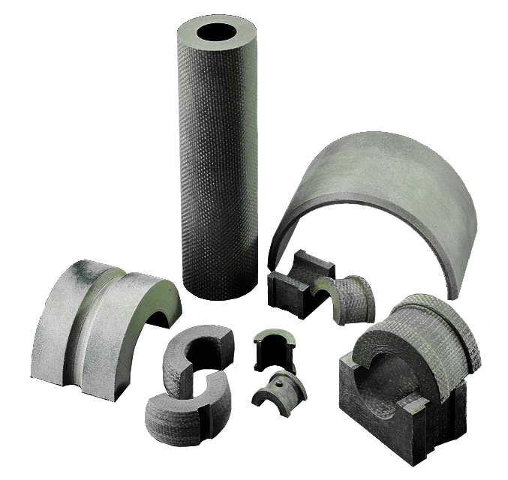
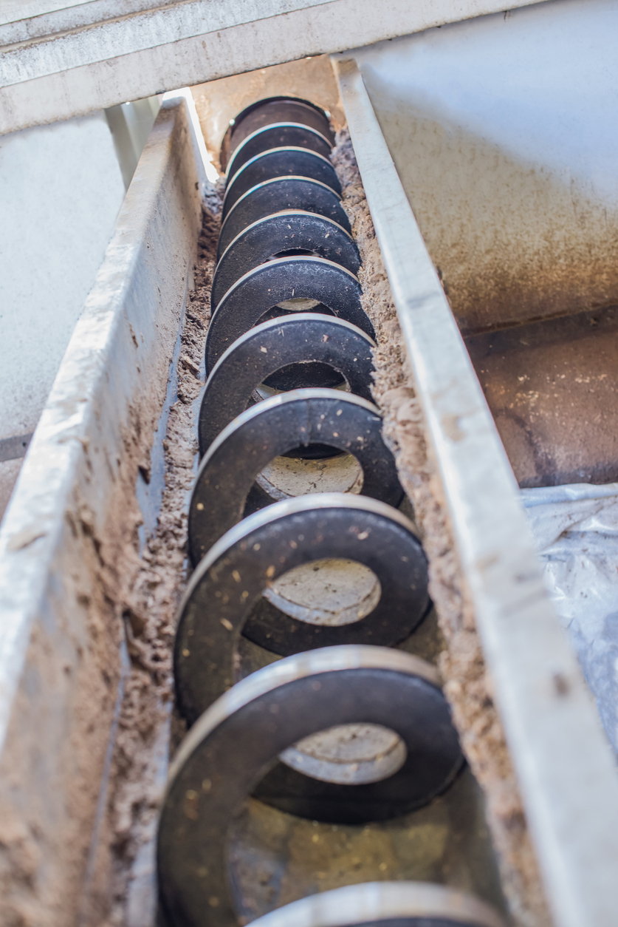 |  | 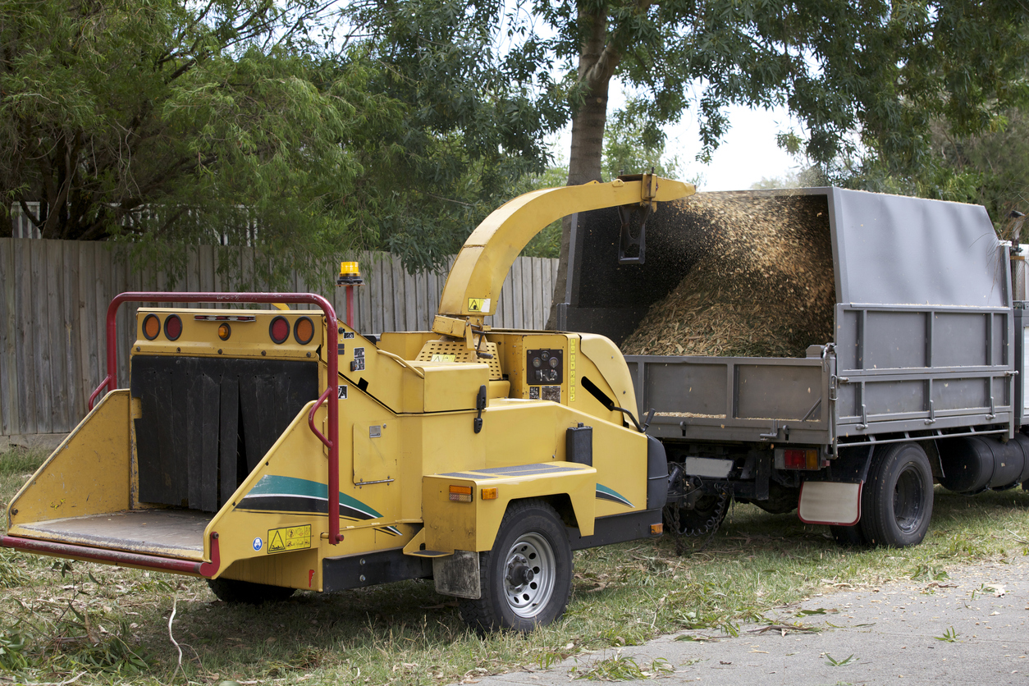

Gatke bearing materials are also excellent for use on the applications that require high compressive strength and shock load. The outstanding mechanical properties of Gatke materials allow the bearings to operate under severe edge loading conditions. Generally, Gatke bearings fit within the same design envelope as traditional bronze bearings.
Typical applications for Gatke Bearings and Wear Products cover a wide range of industries, including:
- Rail and Transit
- Construction Equipment
- Metal Rolling Mills (Aluminum and Steel)
- Paper and Pulp Mills, Chemical Processing Plants
- Mining, Crushing, and Grinding Equipment
- Water Processing Plants
- Machine Press Wear Guides
- Several Others
Scan-Pac Mfg. is a manufacturer of non-asbestos friction materials and phenolic laminates for use in a wide range of industrial and oilfield applications. The company has three manufacturing locations that include two facilities in Menomonee Falls, Wisconsin and one in Magnolia, Texas. Scan-Pac employs more than 100 individuals and has proudly and successfully been in business for more than 45 years.
Thanks and best regards,
Jeff Lichey
VP, Sales & Marketing

